MODULE 5 QUES 5
https://www.hackerearth.com/problem/algorithm/prime-numbers/
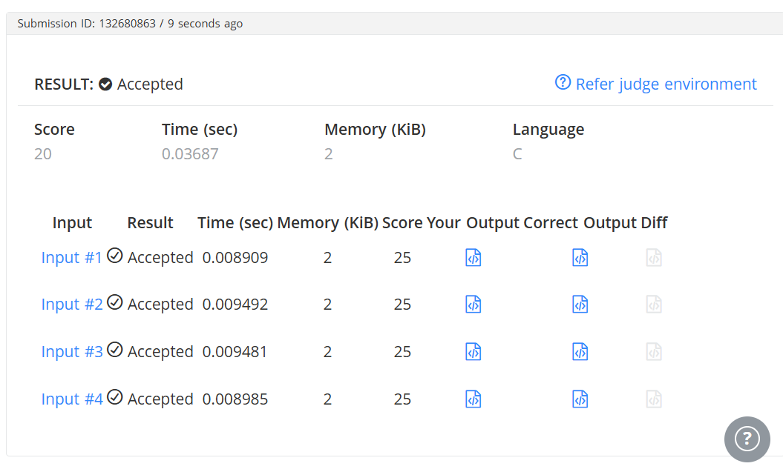
CODE
#include <stdio.h>
int main() {
int n;
// Read the input number from STDIN
if (scanf("%d", &n) != 1) {
return 0;
}
int is_prime = 1; // Assume the number is prime initially
// Check for factors from 2 up to the square root of n
for (int i = 2; i * i <= n; i++) {
if (n % i == 0) {
is_prime = 0; // Found a factor, so it's not prime
break;
}
}

// Print 1 if prime, 0 if not, followed by a newline character (\n)
printf("%d\n", is_prime);
return 0;
}

